Ideation Phase

Brainstorm & Idea Prioritization Template

|  |  |
| --- | --- |
| Date | 22 OCT 2022 |
| Team ID | PNT2022TMID35146 |
| Project Name | IoT based safety gadget for child safety  monitoring and notification |
| Maximum Marks | 4 Marks |

TEAM MEMBERS:

1.SUGAN.S

2.SUDHAKAR.M

3.PRAKALATHAN.R

4.SURESH RAJA.E

Brainstorm & Idea Prioritization:

Step-1: Team Gathering, Collaboration and Select the Problem Statement

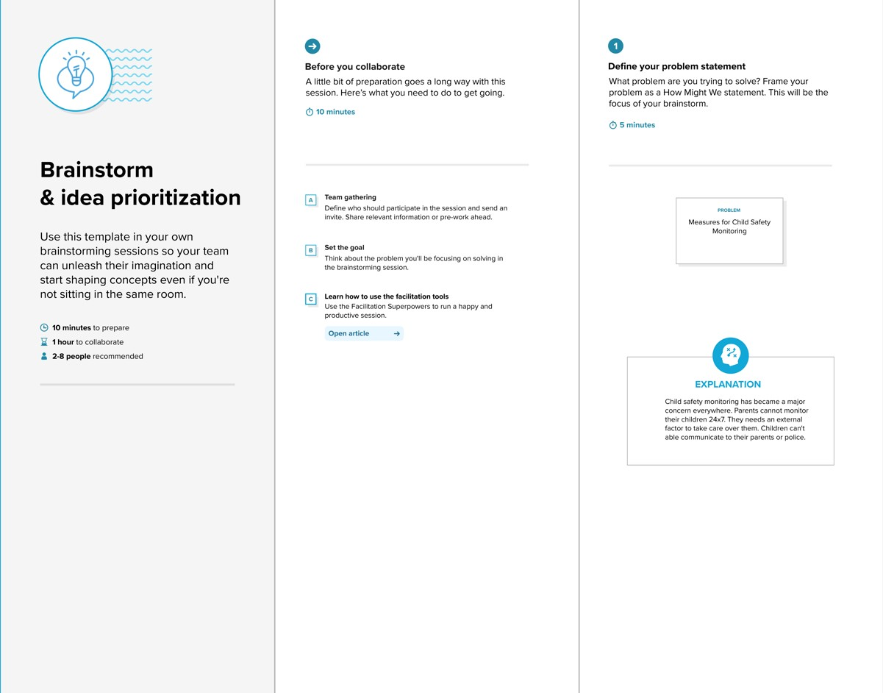

**Step-2: Brainstorm, Idea Listing and Grouping**

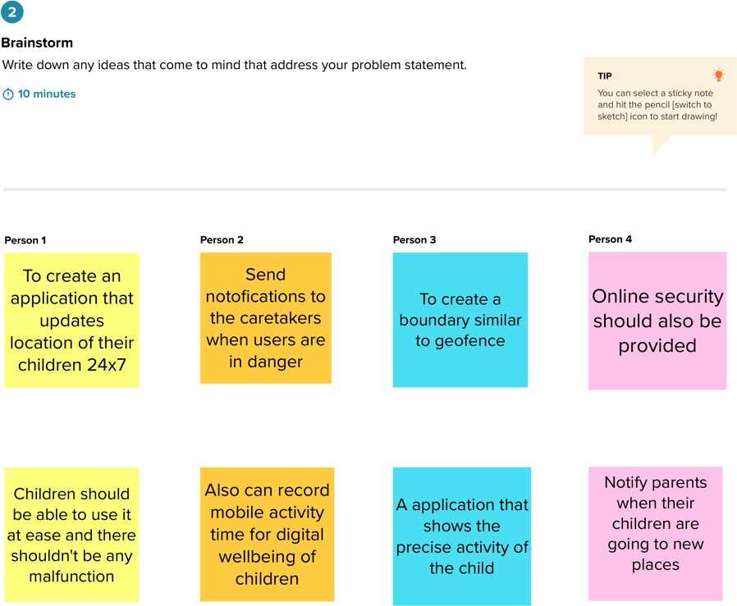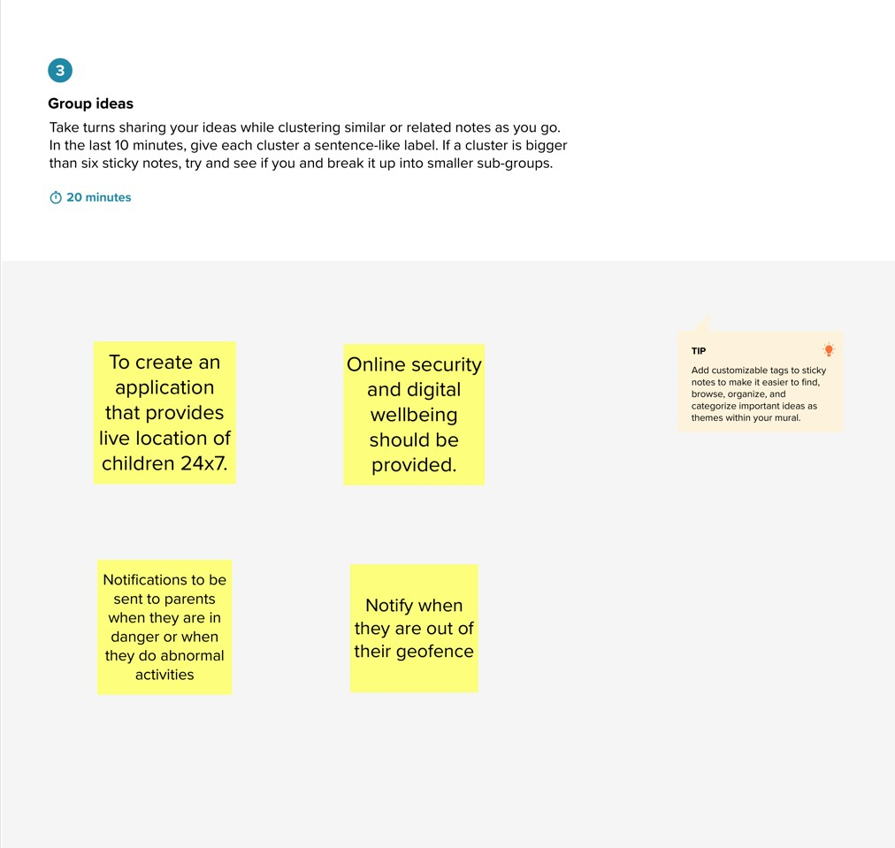

**Step-3: Idea Prioritization**

